SOURCE CODE

#include <Wire.h>
#include <SoftwareSerial.h>
#include <LiquidCrystal_I2C.h>

SoftwareSerial mySerial(9,10);
char msg;
char call;
LiquidCrystal_I2C lcd(0x27, 16, 2);
int ledPin = 3;
int buzzer = 2;

byte zero[] = {
B00000,
B00000,
B00000,
B00000,
B00000,
B00000,
B00000,
B00000
};
byte one[] = {
B10000,
B10000,
B10000,
B10000,
B10000,
B10000,
B10000,
B10000
};

byte two[] = {
B11000,
B11000,
B11000,
B11000,
B11000,
B11000,
B11000,
B11000
};

byte three[] = {
B11100,
B11100,
B11100,
B11100,
B11100,
B11100,
B11100,
B11100
};

byte four[] = {
B11110,
B11110,
B11110,
B11110,
B11110,
B11110,
B11110,
B11110
};

byte five[] = {
B11111,
B11111,
B11111,
B11111,
B11111,
B11111,
B11111,
B11111
};

void setup(){
digitalWrite(4, HIGH);
delay(1000);
digitalWrite(4, LOW);
delay(5000);
lcd.init();
lcd.backlight();
digitalWrite(ledPin, HIGH);
pinMode(ledPin, OUTPUT);
pinMode (buzzer, OUTPUT);
lcd.createChar(0, zero);
lcd.createChar(1, one);
lcd.createChar(2, two);
lcd.createChar(3, three);
lcd.createChar(4, four);
lcd.createChar(5, five);
mySerial.begin(9600);
Serial.begin(9600);
}

void loop(){
int pirState=digitalRead(6);
if (pirState == LOW){
lcd.setCursor(0,0);
lcd.print("PUT OBJECT");
lcd.setCursor(0,1);
lcd.print("TO DISINFECT");
delay(500);

}

else if (pirState == HIGH){
delay(3000);
lcd.clear();
lcd.setCursor(0,0);
lcd.print("DISINFECTING:");
delay(500);
digitalWrite(ledPin, LOW);
for(int i=0; i <= 100; i++)
{

lcd.setCursor(0,1);
updateProgressBar(i, 100, 1);
delay(100);
}
delay(1000);
lcd.clear();
lcd.setCursor(0,0);
lcd.print("DONE!!!!");
digitalWrite(ledPin, HIGH);
digitalWrite(buzzer, HIGH);
delay(1000);
digitalWrite(buzzer, LOW);
delay(1000);
digitalWrite(buzzer, HIGH);
delay(1000);
digitalWrite(buzzer, LOW);
delay(1000);
digitalWrite(buzzer, HIGH);
delay(1000);
digitalWrite(buzzer, LOW);

SendMessage();
lcd.clear();
lcd.setCursor(0,0);
lcd.print("DISINFECTION");
lcd.setCursor(0,1);
lcd.print("COMPLETE");
delay(2000);
lcd.clear();
lcd.setCursor(0,0);
lcd.print("PLEASE REMOVE");
lcd.setCursor(0,1);
lcd.print("OBJECT NOW 5");
delay(1000);
lcd.setCursor(0,0);
lcd.print("PLEASE REMOVE");
lcd.setCursor(0,1);
lcd.print("OBJECT NOW 4");
delay(1000);
lcd.setCursor(0,0);
lcd.print("PLEASE REMOVE");
lcd.setCursor(0,1);
lcd.print("OBJECT NOW 3");
delay(1000);
lcd.setCursor(0,0);
lcd.print("PLEASE REMOVE");
lcd.setCursor(0,1);
lcd.print("OBJECT NOW 2");
delay(1000);
lcd.setCursor(0,0);
lcd.print("PLEASE REMOVE");
lcd.setCursor(0,1);
lcd.print("OBJECT NOW 1");
delay(1000);
lcd.setCursor(0,0);
lcd.print("PLEASE REMOVE");
lcd.setCursor(0,1);
lcd.print("OBJECT NOW 0");
delay(1000);
lcd.clear();
digitalWrite(pirState, LOW);
delay(5000);
}
}

void updateProgressBar(unsigned long count, unsigned long totalCount, int lineToPrintOn)
{
double factor = totalCount/80.0;
int percent = (count+1)/factor;
int number = percent/5;
int remainder = percent%5;
if(number > 0)
{
lcd.setCursor(number-1,lineToPrintOn);
lcd.write(5);
}

lcd.setCursor(number,lineToPrintOn);
lcd.write(remainder);
}

void SendMessage()
{
mySerial.println("AT+CMGF=1");
delay(1000);

mySerial.println("AT+CMGS=\"+639750710500\"\r");
delay(1000);

mySerial.println("DISINFECTED");
delay(100);
mySerial.println((char)26);
delay(1000);
}

SCHEMATIC DIAGRAM

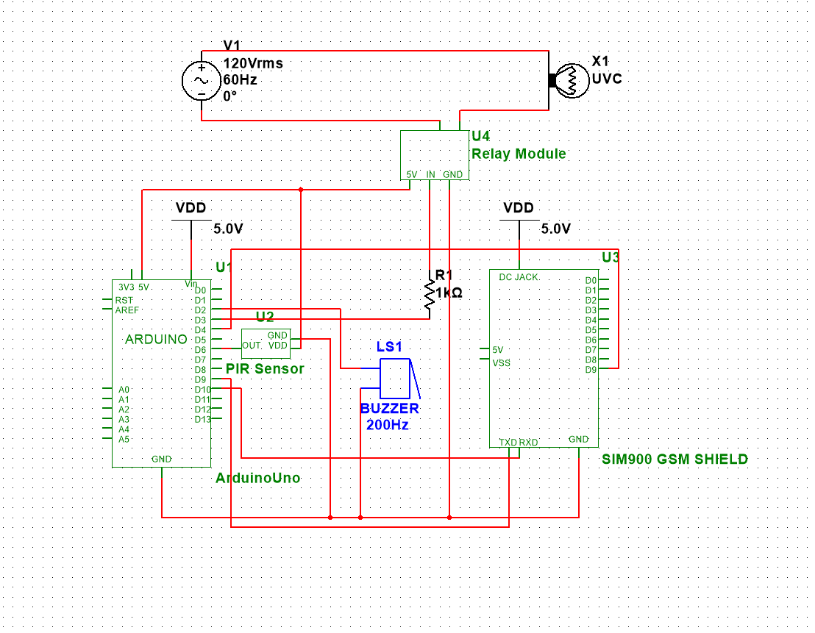

FABRICATION OF THE DEVICE

First, connect the GND pins of PIR Sensor, Buzzer, SIM900, and Relay Module to the GND pin of Arduino. Then, connect the source pin of PIR Sensor and Relay Module to the 5V pin of Arduino. After that, connect the TXD and RXD pins of SIM900 to pins 9 and 10 of Arduino respectively. Connect pin 2 of Arduino to the positive pin of the buzzer, then connect the OUT pin of PIR Sensor to pin 6 of Arduino. After that, connect the pin 9 of SIM900 to pin 4 of Arduino. And then connect the pin 3 of Arduino to a 1k resistor then connect the other end of the resistor to the IN pin of Relay Module. Lastly, connect an AC source to the relay module to power up the UVC lamp.

